Mrs. Muldoon Name______________________________
English 9A
The Odyssey: Book 12 Journal
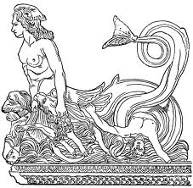
1. Odysseus chooses not to warn his crew about Scylla and Charybdis. Why does he make this decision? What does this tell us about his character?
Directions: Choose one of the following prompts and write a 1 page response that uses specific examples and details to support your ideas.

2. Based on the speech Odysseus gives his men (140-160), has he changed since the beginning of the story when he confronted the Cyclops? Explain your opinion with support from the text.
3. Read “The Siren Song” on pg. 938 and consider the nature of the appeal the Siren makes in Atwood’s poem. Based on what you know about Odysseus, how do you think he would respond?

Mrs. Muldoon Name______________________________
English 9A
The Odyssey: Book 12 Journal
1. Odysseus chooses not to warn his crew about Scylla and Charybdis. Why does he make this decision? What does this tell us about his character?
Directions: Choose one of the following prompts and write a 1 page response that uses specific examples and details to support your ideas.

2. Based on the speech Odysseus gives his men (140-160), has he changed since the beginning of the story when he confronted the Cyclops? Explain your opinion with support from the text.
3. Read “The Siren Song” on pg. 938 and consider the nature of the appeal the Siren makes in Atwood’s poem. Based on what you know about Odysseus, how do you think he would respond?

