The Odyssey: Book 9 Journal
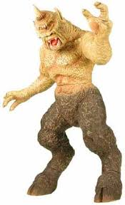
1. Is Odysseus’ curiosity a mark of his intelligence or a character flaw? Use examples from Book 9 to support your opinion.
2. Do you consider Polyphemus a villain? Do Odysseus’ actions toward him seem justified? Explain, referencing specific quotes from Book 9.
3. From the characterization of Polyphemus, what conclusion can you draw about the qualities that ancient Greek society considered barbaric or monstrous? Use specific examples from Book 9 to support your opinion.
Directions: Choose one of the following prompts and write a 1 page response that uses specific examples and details to support your ideas.

Mrs. Muldoon Name________________________________
English 9A
The Odyssey: Book 9 Journal
1. Is Odysseus’ curiosity a mark of his intelligence or a character flaw? Use examples from Book 9 to support your opinion.
2. Do you consider Polyphemus a villain? Do Odysseus’ actions toward him seem justified? Explain, referencing specific quotes from Book 9.
3. From the characterization of Polyphemus, what conclusion can you draw about the qualities that ancient Greek society considered barbaric or monstrous? Use specific examples from Book 9 to support your opinion.
Directions: Choose one of the following prompts and write a 1 page response that uses specific examples and details to support your ideas.

