Name _________________________
The Odyssey Reading Guide
Book 1: The Invocation
1. What qualities does Odysseus have that prove he’s an epic hero?

Book 9: New Coasts and Poseidon’s Son
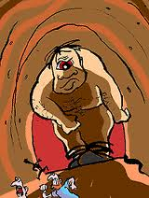
2. Odysseus begins Book 9 with a preview of what’s to come. Summarize lines 1-28: The ________ have made Odysseus’ journey more difficult. He was held captive by the goddesses _____________ and _____________ on their islands. Odysseus desires to go __________. Odysseus was trying to get home from _____________ where he fought a battle over ____________________________________________________.
3. What happened to Odysseus and his men after he left Troy?

4. What happened to people that ate the Lotus Flower?
5. Can you infer what the Greeks valued about themselves, based on Odysseus’ description of the Cyclopes? Explain.

6. “Young Dawn with the fingertips of rose” is an example of an _________________.
7. Why does Odysseus mention the gods when he requests hospitality and the custom of “xenia” (163-175)?
8. What is the Cyclopes attitude toward the gods (175-184)?

9. How does Odysseus display his heroic qualities in lines 284-285?

10. Summarize all the steps in Odysseus’ plan to trick and escape the Cyclopes.
1.
2.
3.
4.
5.
11. The Cyclops’ name is _______________ (line # ) and his father is _____________(line # ).
12. How does the tone change during Polyphemus’ speech in lines 360-373?
The beginning:
The end:

13. Why does Odysseus reveal his true identity to Polyphemus? What does this reveal about his character?

14. Summarize the Cyclops’ plea to Poseidon (443-452):

Book 10: The grace of the witch
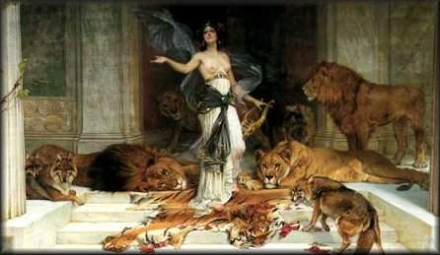
16. Briefly, they stop in the land of the ___________________, who are ________ and only _________ of Odysseus’ men survive the boulders launched at their ships.
17. Next, they land on the island of ___________, home to the goddess ____________.
15. Where do Odysseus and his men land after the island with the Cyclops? How does King Aeolus help them?
18. How did Circe trick Odysseus’ men? What did she turn them into?

19. How does the god Hermes help Odysseus defend himself against Circe?

20. What does Odysseus make Circe promise (70-80)?

21. Summarize Eurylochus’ criticism of Odysseus (140-146):

22. In line 177, for the second time, Odysseus says “we were men, we could not help consenting.” What does he mean by this?
23. Odysseus and his men stayed on Circe’s island for another whole _________ (179).
24. Supplication means ___________________________________________(192).
25. Where does Odysseus have to go, per Circe’s request, before return home (200-210)?

26. In book 11, Odysseus and his men visit the ________________ where the prophet _______________ warns Odysseus that he and his men must act with _____________ and ________________.

Book 12: Sea perils and defeat
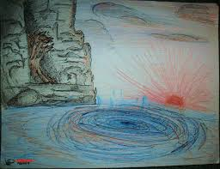
29. Odysseus must pass _________ who will gobble up at least ____ men when they pass.
30. Describe Charybdis (59-68):
27. What is a Siren?
28. Circe warns Odysseus and his men to steer ________; keep _______________; and _________________the oarsmen’s ____________________________.

31. Why does Circe tell Odysseus to take his chances with Scylla instead of Charybdis?
32. Do you think Odysseus and his men will steer clear of the Island of Helios as Circe warns? Why or why not?
33. How does Odysseus motivate his men to continue past the sea dangers ahead (141-
160)?
34. Odysseus’ men refuse to bypass _____________, the island of the sun god _______.
They feast on his cattle, which makes Helios angry. __________ sinks Odysseus’ ship and ___________________ is the only one to ____________.
35. Odysseus floats to _________, where ___________ lives. She keeps him for ____ years before he returns home.

Books 13-16: The Phaecians help Odysseus get home even though this anger Poseidon. Odysseus arrives on Ithaca and disguises himself as a beggar to scout out the land, which is in shambles. One of his old servants, Eumaeus, takes pity on the “bum” and takes him home for a meal While Eumaeus is not around, Odysseus drops his disguise and reveals himself to his son, Telemachus.
Book 17: Odysseus enters the main city. His disguise is so good Penelope and others don’t recognize him. Only a ragged, abandoned dog wags his tail when he sees Odysseus. Eumaeus explains this dog is Argus, Odysseus’ loyal hunting dog. Odysseus cries as Argus dies in his arms. At this, Antinous throws a footstool at the “ragged beggar,” but Penelope yells at Antinous and allows the beggar to stay at the palace.
Book 18: Another beggar, Irus, gets enraged and tries to bully Odysseus for intruding in his favorite panhandling location. Aninous, bored and filled with bloodlust, arranges a boxing match between the two. They are surprised with wiry Odysseus displays muscles by breaking Irus’ jaw. Odysseus finds out that the suitors are abusing the maidservants.
Book 19: Eurycleia, an aged nurse who cared for Odysseus when he was a child, sees through his disguise. Penelope declares her decision: she will marry whichever suitor can duplicate her husband’s feat of shooting an arrow through 12 straight rows of axes after stringing his bow.
Book 20: That night, Odysseus and Penelope both toss and turn, worrying about the outcome of the event. Penelope prays that she die before she is ever forced to marry one of the repulsive suitors. The suitors put in motion their plan to kill Telemachus.

Book 21: the test of the bow
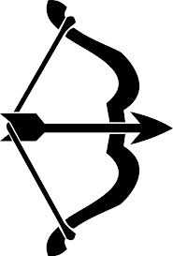
38. Summarize the order Odysseus gives to the cowherd and swineherd (94-104):
39. Based on his orders, what do you think Odysseus is planning?
40. Based on Penelope’s response to Antinous in lines 141-150, does she recognize Odysseus?
36. What emotions is Penelope feeling in lines 1-14 and how do you know that?

37. What adjectives describe Antinous based on lines 33-43?

41. Describe the epic simile in lines 197-206:
42. What is ironic about Odysseus’ comments in lines 220-227?

Book 22: death in the great hall
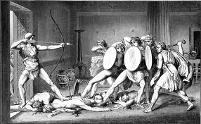
44. Why is the uproar of the other suitors toward Odysseus ironic (258-265)?
45. What three reasons does Odysseus give for seeking revenge against the suitors (267-269)?
46. How does Athena, goddess of _______________, help Odysseus win the battle against the suitors?
43, Why does Odysseus kill ______________ first?

Book 23: the trunk and the olive tree 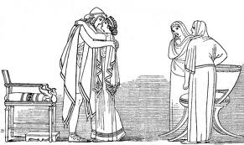
47. Why does Penelope ask the Eurycleia to move the bed that she knows cannot be moved (385-411)?
48. Why does Penelope beg Odysseus not to be angry with her?

49. Do you think Odysseus had a right to kill the suitors? Explain.

50. Why do you think Penelope thought of the plan with the bow and arrow? What does this reveal about her character?

