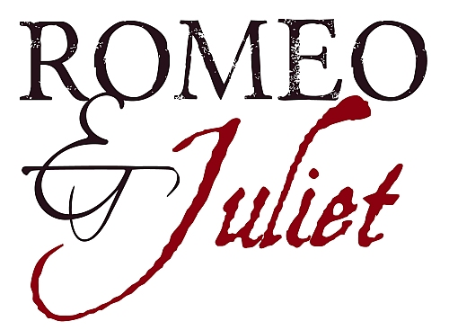
Muldoon My name is _______________________________.
English 9 Advanced
Anticipation Guide
Directions: Circle whether you AGREE or DISAGREE with each statement. You must choose a side.
1. Love at first sight is rare, but possible.
AGREE DISAGREE
2. People who are in love often do foolish things.
AGREE DISAGREE
3. If I am attracted to someone, I will figure out a way to see them even if my parents don’t approve.
AGREE DISAGREE
4. Children have a duty to love and obey their parents.
AGREE DISAGREE
5. Teenagers cannot experience “true” love.
AGREE DISAGREE
6. Being separated from the one you love is worse than death.
AGREE DISAGREE
7. Friends are worth defending, no matter the cost.
AGREE DISAGREE
8. Telling lies or avoiding the truth is acceptable if it’s for the right reasons.
AGREE DISAGREE
9. Parents make decisions that are best for their children.
AGREE DISAGREE
10. Sometimes murder is justified if that person is also a murderer.
AGREE DISAGREE
11. “Luck” is a figment of the imagination; it’s not real.
AGREE DISAGREE

12. You should always be loyal to your family, no matter what.
AGREE DISAGREE
Now, choose the statement that you agree with the strongest. Write multiple sentences explaining why you hold that opinion. Feel free to include personal experiences, other people’s experiences, things you’ve seen in movies, heard, etc. (You should fill all the lines!)
________________________________________________________________________________________________________________________
________________________________________________________________________________________________________________________
________________________________________________________________________________________________________________________
________________________________________________________________________________________________________________________

Characters

Montagues:

Capulets:

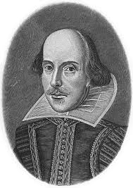
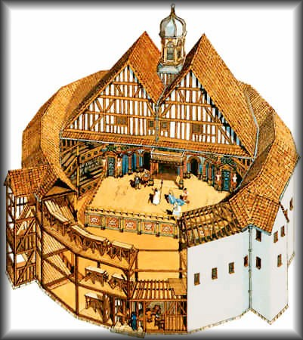
Other:
Muldoon
English 9A
Notes on William Shakespeare
Shakespeare was born in _______________________________
in the year ________________.
His father, ________________________________, was a
______________________________.
Shakespeare attended ______________________ school,
where he learned the subjects of: ___________________,
_______________________, and _____________________________.
He never attended ____________________________________.
Since he never attended college, some people question whether or not he is the real ______________________ of the numerous plays and sonnets he wrote.
Shakespeare married ______________________________________. They had __________ children.
Eventually Shakespeare moved to London to join an acting troupe called ______________ ________________________________________.
He wrote ____________ plays including: ______________________________ , _________________________
and ___________________________. He also wrote ____________ sonnets.
Write down 2 other interesting facts you discovered about Shakespeare:
1.
2.
Muldoon
English 9A
Notes on the Globe Theatre
The Globe Theatre is in ________________________.
The top is ____________, in order to let in
_______________________, since there is no
________________________. Plays were performed in
the __________________________________.

It has _______________ sides which makes it
resemble a ______________________.
Describe the props and the sets:
_____________________________________________________
_____________________________________________________
Describe the typical costumes:
________________________________________________________________________________________________________
Admission to a play cost ___________________ which was comparable to ________ day’s wage.
Today that would mean around ____________ dollars.
How would they notify people that there would be a play that day?___________________________
Describe the atmosphere of the plays:
________________________________________________________________________________________________________
Additional Information:
Muldoon
English 9A
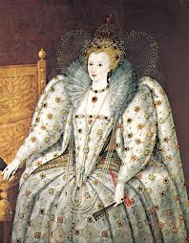

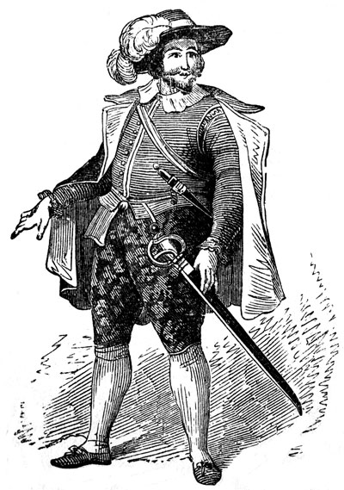
Elizabethan England
What is a monarchy?_________________________________________
________________________________________________________________.
Queen ______________________________ was the monarch for
most of Shakespeare’s life.
Describe the typical woman’s clothes during this era:
________________________________________________________________
________________________________________________________________
Describe the typical man’s clothes during this era:
________________________________________________________________
________________________________________________________________
What food did the poorer people eat?
________________________________________________________________
What food did the wealthy eat?
________________________________________________________________
List at least 4 common jobs:
________________________________________________________________
________________________________________________________________
The main religion of the time was _________________________.
Why did they drink ale instead of water?
________________________________________________________________
Write down 2 other interesting facts you learned about the Elizabethan Era:
1.

2.
Iambic Pentameter Notes
Shakespeare’s predominant meter was ________________________. A unit of iambic meter, called an __________________________, consists of a _______________________ followed by a _____________________: da-DUM.
Examples of words that fit this meter: _____________________ ____________________
_____________________ ____________________
Shakespeare wrote most of his poetry in ________________________ ______________________, ________________ _________________ of iambic beat to a line:
“But SOFT, what LIGHT through YONder WINdow BREAKS.”
“da DUM, da DUM da DUM da DUM da DUM.”
The Shakespearean Sonnet
Shakespeare did not invent the __________________________ sonnet form, but he is recognized as its greatest practitioner; therefore, the English sonnet is commonly called the Shakespearean sonnet.
The Shakespearean sonnet consist of _______________________________ (four-line stanzas), rhyming abab, cdcd, efef, and a ________________________ (two-line stanza), rhyming gg. Because each new stanza introduces a new set of rhyming sounds, the Shakespearean sonnet is well suited to English whish is less richly endowed than Italian with rhyming words.
Directions:
1. Underline the last word in each line and then label the lines according to the rhyming scheme. (abab, cdcd, efef, gg)
2. Draw a [bracket] around each quatrain and the couplet.
3. Label the unstressed and stressed syllable in two lines of your choosing.
u /
Sonnet 18
Shall I compare thee to a summer's day?
Thou art more lovely and more temperate:
Rough winds do shake the darling buds of May,
And summer's lease hath all too short a date:
Sometime too hot the eye of heaven shines,
And often is his gold complexion dimm'd;
And every fair from fair sometime declines,
By chance, or nature's changing course, untrimm'd;
But thy eternal summer shall not fade
Nor lose possession of that fair thou ow'st;
Nor shall Death brag thou wander'st in his shade,
When in eternal lines to time thou grow'st;
So long as men can breathe or eyes can see,
So long lives this, and this gives life to thee.
What’s your reaction to hearing Shakespeare as a rap? Explain…

YOUR TURN! Write a sonnet.
It should follow the same line format: 3 quatrains with a couplet with the ABAB, CDCD, EFEF, GG rhyme scheme. Don’t worry about having 10 syllables per line or following stressed/unstressed rule.
Muldoon
English 9

Dramatic Literary Terms

Verse

Rhymed Verse
    - Contains a ___________________________
    - Used intermittently when Romeo and Juliet are speaking of their _______________ for one another and/or when a ________________________ is passionate about something. (Sometimes nobility will end a speech with rhymed verse.)
3. EX: Act I, scene v: Romeo says to Juliet,
“If I profane with my unworthiest hand
This holy shrine, the gentle sin is this:
My lips, two blushing pilgrims, ready stand
To smooth that rough touch with a tender kiss.”

Free Verse/Blank Verse
    - Contains a ___________________________
    - Used by _______________ and the _________________
3. EX: Act I, scene i: Lord Montague tells Benvolio,
“Both by myself and many other friends;
But he, his own affections’ counselor,
Is to himself—I will not say how true—
But to himself so secret and so close,”

Prose
    - Written like ___________________ language (no _________________ or __________________ scheme)
    - Used by _______________________ when losing their minds and/or by ___________________________
3. EX: Act I, scene i: Sampson tells Abraham:
“Nay, as they dare. I will bite my thumb at them, which is disgrace to them, if they bear it.”

Dramatic Literary Terms (Cont.)

Speeches/Dialogue

Monologue
    - A _______________ speech made by _________ character to _______________ characters (and the ____________________)
    - EX: Act I, Scene iv: Mercutio,
“O, then I see Queen Mab hath been with you.
She is the fairies’ midwife, and she comes
In shape no bigger than an agate stone
On the forefinger of an alderman…”

Soliloquy
    - A ____________ speech made by _________ character to ___________________ (and the _____________________)
    - EX: Act II, Scene ii: Juliet,
“’Tis but thy name that is my enemy.
Thou art thyself, though not a Montague.
What’s Montague? It is nor hand, nor foot,
Nor arm, nor face, nor any other part…”

Aside
    - A remark __________________ by _______ character to _________________________, which other characters are ______________ ___________________________________
    - EX: Act I, Scene i: Sampson’s “Is the law of our side if I say ay?” (to Gregory)

Literary Devices

Pun
    - A _____________ on words.
    - EX: Act III, Scene i: Mercutio says, “Ask for me tomorrow and you shall find me a grave man.”
    - Your example:

Foil
    - A character who provides a ________________ ____________________ to another character. They’re ______________________.
    - EX: Act I: Love-sick/romantic Romeo and fiery Tybalt
    - Your example:

Juxtaposition
    - Two ________________________ scenes placed next to each other to add _______________________.
    - EX: Act Two, Scene i: Mercutio’s dirty-mouthed views of love and Act Two, Scene ii: “The Balcony Scene” in which Romeo and Juliet express their pure love for one another.
    - Your example:

Dramatic Irony
    - When the ______________________ knows something that the ____________________.
    - EX: Act III, Scene i: Romeo does not want to fight Tybalt because he has married Juliet. (Romeo knows, the audience knows, but the other characters in the scene do not.)
    - Your example:

Act 1

Act 2

Act 4

Act 5

Muldoon Name _______________________________
English 9A
Romeo & Juliet Prologue
Two households, both alike in dignity,
In fair Verona, where we lay our scene,
From ancient grudge break to new mutiny,
Where civil blood makes civil hands unclean.
From forth the fatal loins of these two foes
A pair of star-cross'd lovers take their life;
Whose misadventured piteous overthrows
Do with their death bury their parents' strife.
The fearful passage of their death-mark'd love,
And the continuance of their parents' rage,
Which, but their children's end, nought could remove,
Is now the two hours' traffic of our stage;
The which if you with patient ears attend,
What here shall miss, our toil shall strive to mend.
Directions:
1. Underline all words related to love in RED.
2. Underline all words related to fighting in BLACK.
3. Circle every example of the word “two.’
4. Are there more words that pertain to fighting or love? Based on that finding, what do you predict will unfold throughout Romeo & Juliet? Be specific.
5. Why do you think Shakespeare emphasizes the number two?
Tips when paraphrasing:

Two households, both alike in dignity,
_______________________________________________________________________________
In fair Verona, where we lay our scene,
_______________________________________________________________________________
From ancient grudge break to new mutiny,
_______________________________________________________________________________
Where civil blood makes civil hands unclean.
_______________________________________________________________________________
From forth the fatal loins of these two foes
_______________________________________________________________________________
A pair of star-cross'd lovers take their life;
_______________________________________________________________________________
Whose misadventured piteous overthrows
_______________________________________________________________________________
Do with their death bury their parents' strife.
_______________________________________________________________________________
The fearful passage of their death-mark'd love,
_______________________________________________________________________________
And the continuance of their parents' rage,
_______________________________________________________________________________
Which, but their children's end, nought could remove,
_______________________________________________________________________________
Is now the two hours' traffic of our stage;
_______________________________________________________________________________
The which if you with patient ears attend,
_______________________________________________________________________________
What here shall miss, our toil shall strive to mend.
_______________________________________________________________________________

Act 1 Vocabulary
Adversary Definition:______________________________________________________________________________________________________
Part of speech: _______________________________________
Use the word in a sentence: ________________________
_________________________________________________________________________________________________________________
Draw a picture that represents the word:
Pernicious
Definition:______________________________________________________________________________________________________
Part of speech: _______________________________________
Use the word in a sentence: ________________________
_________________________________________________________________________________________________________________
Draw a picture that represents the word:

Grievance
Definition:______________________________________________________________________________________________________
Part of speech: _______________________________________
Use the word in a sentence: ________________________
_________________________________________________________________________________________________________________
Draw a picture that represents the word:
Augmenting Definition:______________________________________________________________________________________________________
Part of speech: _______________________________________
Use the word in a sentence: ________________________
_________________________________________________________________________________________________________________
Draw a picture that represents the word:

Transgression
Definition: ______________________________________________ Draw a picture that represents the word:
___________________________________________________________
Part of speech: _________________________________________
Use the word in a sentence: __________________________
___________________________________________________________
___________________________________________________________
___________________________________________________________

Act 2 Vocabulary
Intercession
Definition:______________________________________________________________________________________________________
Part of speech: _______________________________________
Use the word in a sentence: ________________________
_________________________________________________________________________________________________________________
Draw a picture that represents the word:
Procure
Definition:______________________________________________________________________________________________________
Part of speech: _______________________________________
Use the word in a sentence: ________________________
_________________________________________________________________________________________________________________
Draw a picture that represents the word:

Unwieldy
Definition:______________________________________________________________________________________________________
Part of speech: _______________________________________
Use the word in a sentence: ________________________
_________________________________________________________________________________________________________________
Draw a picture that represents the word:
Lamentable
Definition:______________________________________________________________________________________________________
Part of speech: _______________________________________
Use the word in a sentence: ________________________
_________________________________________________________________________________________________________________
Draw a picture that represents the word:

Sallow
Definition: ______________________________________________ Draw a picture that represents the word:
___________________________________________________________
Part of speech: _________________________________________
Use the word in a sentence: __________________________
___________________________________________________________
___________________________________________________________
___________________________________________________________

Act 3 Vocabulary
Exile
Definition:______________________________________________________________________________________________________
Part of speech: _______________________________________
Use the word in a sentence: ________________________
_________________________________________________________________________________________________________________
Draw a picture that represents the word:
Gallant
Definition:______________________________________________________________________________________________________
Part of speech: _______________________________________
Use the word in a sentence: ________________________
_________________________________________________________________________________________________________________
Draw a picture that represents the word:

Ambiguities
Definition:______________________________________________________________________________________________________
Part of speech: _______________________________________
Use the word in a sentence: ________________________
_________________________________________________________________________________________________________________
Draw a picture that represents the word:
Eloquence
Definition:______________________________________________________________________________________________________
Part of speech: _______________________________________
Use the word in a sentence: ________________________
_________________________________________________________________________________________________________________
Draw a picture that represents the word:

Fray
Definition: ______________________________________________ Draw a picture that represents the word:
___________________________________________________________
Part of speech: _________________________________________
Use the word in a sentence: __________________________
___________________________________________________________
___________________________________________________________
___________________________________________________________

Act 4/5 Vocabulary
Dismal
Definition:______________________________________________________________________________________________________
Part of speech: _______________________________________
Use the word in a sentence: ________________________
_________________________________________________________________________________________________________________
Draw a picture that represents the word:
Pensive
Definition:______________________________________________________________________________________________________
Part of speech: _______________________________________
Use the word in a sentence: ________________________
_________________________________________________________________________________________________________________
Draw a picture that represents the word:

Kindred
Definition:______________________________________________________________________________________________________
Part of speech: _______________________________________
Use the word in a sentence: ________________________
_________________________________________________________________________________________________________________
Draw a picture that represents the word:
Loathsome
Definition:______________________________________________________________________________________________________
Part of speech: _______________________________________
Use the word in a sentence: ________________________
_________________________________________________________________________________________________________________
Draw a picture that represents the word:

Disperse
Definition: ______________________________________________ Draw a picture that represents the word:
___________________________________________________________
Part of speech: _________________________________________
Use the word in a sentence: __________________________
___________________________________________________________
___________________________________________________________
___________________________________________________________

