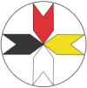 | Teen Life on an Indian Reservation  From: http://www.medicinewhl.org/situatione.htm  © 2015 Medicine Wheel Healing Community  Last Updated 8-16-2015

Home | About | News | Programs | Resources | Support | In Memorium | Contact

Native American children are facing many problems that make it difficult for them to grow up in happy, healthy lifestyles.
Traditional Lakota values were replaced with non Indian values bringing about a life style that has led to the worst statistics in health, education, employment, housing, legal rights, etc. As one U.S. Attorney has stated, “Native Americans are the most victimized group in America”.
The Child Protection Office of the State of South Dakota has stated that over 60% of the children in foster care are Native American. (State population of Native Americans is 10%) Similar statistics apply for the native youth in state criminal justice institutions.
Alcohol and drugs are major causes for the breakdown of the family unit. Alcoholism affects 8 out of 10 families on most Reservations and has devastated Native Americans spiritually, culturally, emotionally, physically and politically for over a century.
This ongoing generational sickness has caused high numbers in Fetal Alcohol Syndrome & Effects (FASE), Drug Addiction, Bipolarity and other forms of mental illness. Presently, the gang influence is causing the most damage in youth behaviors leading to the high numbers in school drop outs, crimes, health issues, and suicides.
Programs have been developed on the reservations that are addressing these problems but they fall short of the actual needs due to the complexity of the problems.

Up

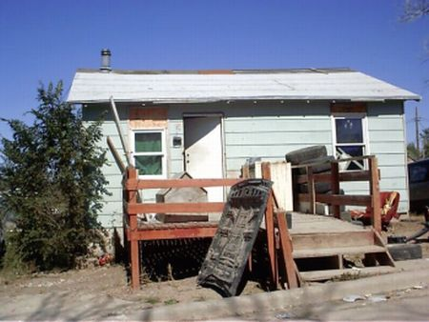 | Housing  The housing shortage on Pine Ridge reservation is large and the waiting list for housing is long. There are families that live for months in a tent or a car, even in wintertime. Others live with many persons in one house under very poor conditions. On an average, 17 people live in a house that is built for a family of four. Up to 30 people have been reported in one home built for eight.  Most houses are badly insulated and have insufficient heating. Approximately. 40 % of the households are without electricity.
Often the houses are lacking stoves, refrigerators, beds and other furniture. Over 400 homes have water delivered by the Oglala Sioux Rural Water Supply. Water is stored in fifty-gallon containers outside the house but moved inside during the winter months.

Up

Malnutrition
The traditional food of the Native American tribes of the Plains consisted primarily of lean meat, wild vegetables, berries and spring waters. In the early reservation years many families had vegetable gardens and paid attention to their nutrition. Gradually, however, the American way of life found its way into the reservations and along with it fatty meats, too much starchy foods, little fruit and vegetables, highly sugary beverages and a sedentary lifestyle.
Another reason for bad nutrition is lack of money. Most families on the reservation have only a limited budget for food with many family members to feed. Quantity becomes more of a factor than quality; therefore the results are obesity and diet-related health problems

Up

Health/Mental Health  In the previous sections we pointed out some of the conditions leading to health problems in children/youth on the reservation.  Furthermore, much of what endangers the health of the adults also represents a risk for children/youth:  Tuberculosis, pneumonia, alcohol-related car crashes and violence up to homicide, to state some of these risks.  The hospital in Pine Ridge reports on cases of 12-year-old children who had to be treated because of venereal diseases.  Early sexual activity also leads to a high number ofTeen Pregnancies. | 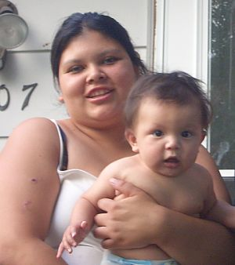
Diabetes
More than 45 % of the adults on the reservation suffer from Diabetes Type II. Diabetes leads to numerous concomitant and after effect diseases along with a high number of dialysis patients.
Cases of Diabetes Type I that is usually found in children/youth are rather rare. But more and more children/youth contract Diabetes Type II. This type of diabetes is related to obesity and a lack in physical exercise.
FAS/E Maternal prenatal alcohol use is one of the leading preventable causes of birth defects and developmental disabilities. One of the most severe outcomes is Fetal Alcohol Syndrome & Effects (FAS/E), which includes abnormalities in three domains at the same time – disorders of the brain, growth retardation, and facial malformations. FAS/E is an irreversible condition that affects every aspect of an individual’s life and the lives of his or her family.
In 8 out of 10 families on the reservation alcohol related problems occur, resulting in a high number of babies born with FAS/E.
One common Mental Health problem is Bi-Polarity or Manic Depressive Disorder. Untreated and in connection with drug use or abuse it can lead to suicide.
Teen Suicide.
Among Native Americans Suicide is the second leading cause of death. The rate of suicide among teens on the reservation is 1.5 times higher than the national average.

Up

Abuse/Sexual Abuse
A recent conference in Rapid City was attended by a tribal judge from Pine Ridge who stated that she presently has 40 ongoing cases of child abuse. Each day there are new cases being investigated by the State Social Services Child Protection Office.
There is a statistic by the Department of Justice stating that the rate for abuse or neglect of Native American children is about double the national rate. And there is also an estimation that 40% of all cases of child abuse and/or neglect are not reported.
One of the worst abuses is the sexual abuse (not only females but also boys). There are cases of children who are sexually abused because the mother had to work – or go drink - and left the child with an unscreened relative or neighbor. Sometimes parents do this to their own children. Kids who have been abused as a child may grow up to become a perpetrator themselves. There are different causes for becoming a perpetrator but one thing is for certain: Sexual abuse of children and youth was not a traditional Native American way of life.
Sexual abuse can lead to changes in school performance, aggressiveness, depression and suicide attempts.

Up

Up

Few leisure time activities  The reservation has many homes in rural areas. Some students will leave home at 6 am to be bussed 50-60 miles one way, picking up students along the way.  The schools promote sports as leisure time activities. Especially basketball is very popular among youth on Pine Ridge Reservation.  Beside sports, the only recreation for youth living in rural areas will be TV, video games and movies.  While some districts of the reservation have youth centers there is no “pick up and drop off” of the students that want to visit these youth centers. | 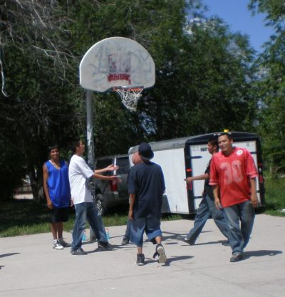

Poverty
Shannon County on South Dakota's Pine Ridge Indian Reservation has more than 51 percent of all people living below the poverty level, along with 57 percent of children under 18.

Medicine Wheel Healing Community was formed in 2010 by Carol Koski, Rollin (Ron) Holton and James Robideau. The dream was to develop a Healing Community which will help Native youth in continuing to recover after alcohol and drug treatment by utilizing practical knowledge and strategies of modern addiction psychology, along with the ancient traditional insight, wisdom, and healing methods of the elders.
Medicine Wheel Healing Community was also planning to hold educational experiences that will lead Native people to healthy lifestyles.
Carol Koski built a two-story building on her property which was near completion when Ron passed away in June 2011. Six weeks later Carol also passed away. The property is up for sale now.
James Robideau, as the only remaining Board Member, found four new Board Members to ensure a fully functional Board.
Medicine Wheel Healing Community is a 501 (C) (3) Non Profit Organization in active status which is incorporated in the State of Nebraska.
Each Board Member has led an active life working to help the Lakota people:

Board of Directors
James Robideau, Dakota Nation | Board Officer, President
Thomas Cook, Mohawk Nation | Board Officer, Secretary
Joseph American Horse, Lakota Nation | Board Officer, Spiritual Advisor
Isabella Schon, German | Board Officer, Treasurer

