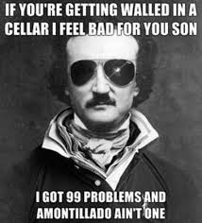
Name ________________________________________
1. In the first paragraph, what phrase used by the narrator is
an example of hyperbole? Write it down. Does this line make
you more sympathetic or less toward the narrator/murderer?
Why?
2. Montresor tells us, “A wrong in unredressed when
retribution overtakes its rederesser. It is equally unredressed
when the avenger fails to make himself felt as such to him who
has done the wrong.” In your own words, explain what this
means.
3. To whom, do you suppose, is Montresor telling this story?
Upon what evidence do you base your assumption?

4. Locate and write down a line that contains verbal irony.

5. At the end of the story, what makes Montresor feel sick?

6. Is Montresor a reliable or unreliable narrator? Explain.

7. Are Montresor’s actions justified based on Fortunado’s crime? Do you think individuals are ever justified in taking justice into their own hands? Explain.

Name ________________________________________
1. In the first paragraph, what phrase used by the narrator is
an example of hyperbole? Write it down. Does this line make
you more sympathetic or less toward the narrator/murderer?
Why?
2. Montresor tells us, “A wrong in unredressed when
retribution overtakes its rederesser. It is equally unredressed
when the avenger fails to make himself felt as such to him who
has done the wrong.” In your own words, explain what this
means.
3. To whom, do you suppose, is Montresor telling this story?
Upon what evidence do you base your assumption?

4. Locate and write down a line that contains verbal irony.

5. At the end of the story, what makes Montresor feel sick?

6. Is Montresor a reliable or unreliable narrator? Explain.

7. Are Montresor’s actions justified based on Fortunado’s crime? Do you think individuals are ever justified in taking justice into their own hands? Explain.

