Royalty, NOBLEMEN, the “upper-class” ate LOTS of meat to flaunt their money.
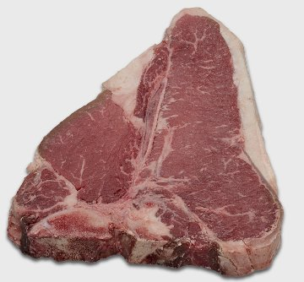
Fun Fact: it was actually “popular” and “sexy” to have rotten teeth because it showed you could afford meat and didn’t have to eat fruits and vegetables like the “commoners.”

The commoners, the “lower-class” ate biscuits, fruits and vegetables that they could grow themselves and dried meats when available. 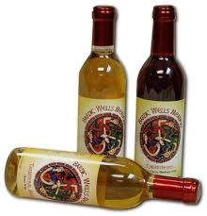
Fun Fact: Elizabethans drank ale or wine because the alcohol would kill the bacteria. Their water was almost too contaminated to drink and would make people sick.
Monarchy
a form of government in which sovereignty is actually or nominally embodied in a single individual; typically passed through a royal bloodline from father to son; kings, queens

Queen Elizabeth and King James = monarchs during Shakespeare’s lifetime
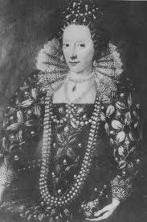

Apothecary
(similar to today’s pharmacist)
Baker
Astrologist
(many believed the alignment of the stars, planets, moon, and sun determined their fate)
Carpenter
Candle-maker
Gardener
Messenger
Painter
Cobbler
(Shoe maker)
Sheriff
Common Jobs during the late 1500s

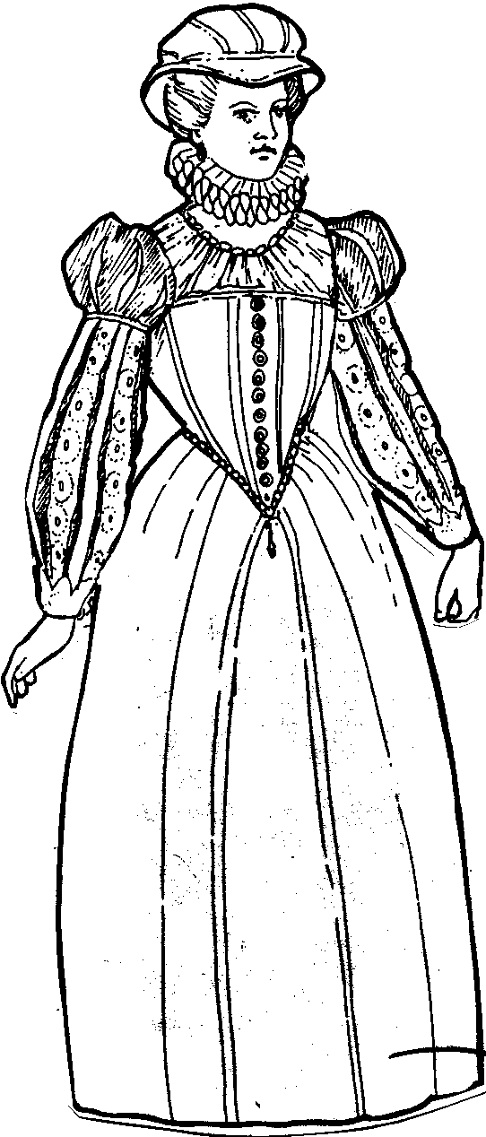

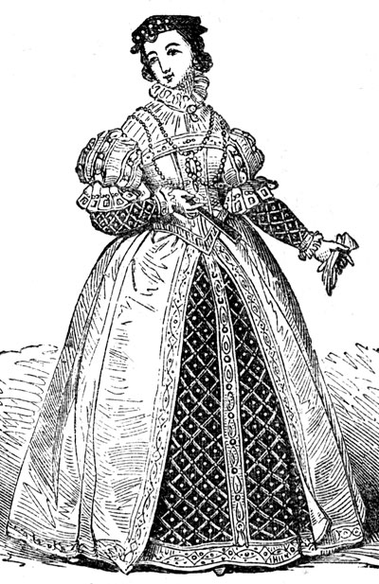

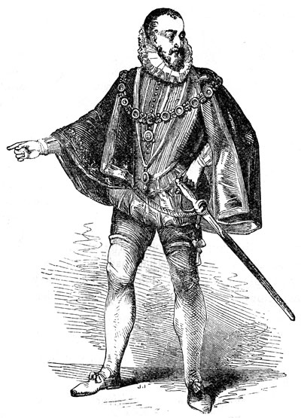

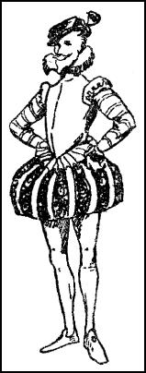

Fun Facts:
Only royalty could wear purple.
The puffier the women’s skirts and the more ruffles on their outfit indicated their economic status.
Men and women wore outfits and hats embellished with jewels, pearls, and stones.
Affluent women’s outfits contained so many layers and pieces, that they required servants to help them dress and pin their puffy sleeves to their dresses.

