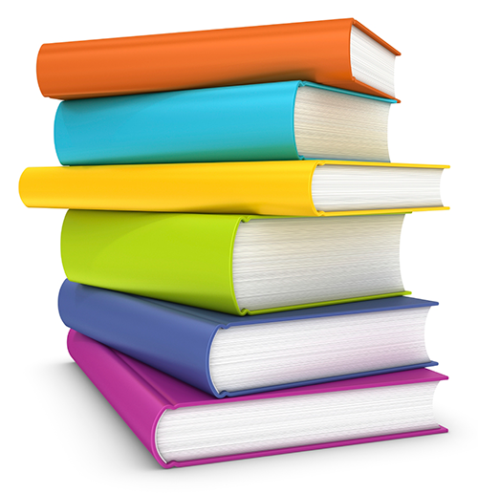
CHOICE NOVEL Assignment

What am I doing? Reading ONE book of your choosing that is at your appropriate reading level. The book can be fiction, non-fiction, or a graphic novel. You can borrow a book from me, check one out from the public library or the school library, or buy it. (Tons of used books can be found on Amazon for a penny + 3.99 shipping = $4!).
When will I read it? On your own time: before school, after school, weekends, Advisory, GPS.
What happens when I’m done reading? You will set up a time to meet with me during GPS to talk about your book. You should be able to answer questions about the plot, the characters, the main point of the book, plus share your opinion. This will be a 5-minute conversation that proves you read the book.

When is this due? All book conversations should be completed by Thursday, October 12th.
Why? My wish is just that you find a book you like! And to start conversations about reading... because even if you think you don’t like reading, I bet there is something you will enjoy!
Based on your Reading Survey, these are some books I think you might like:

