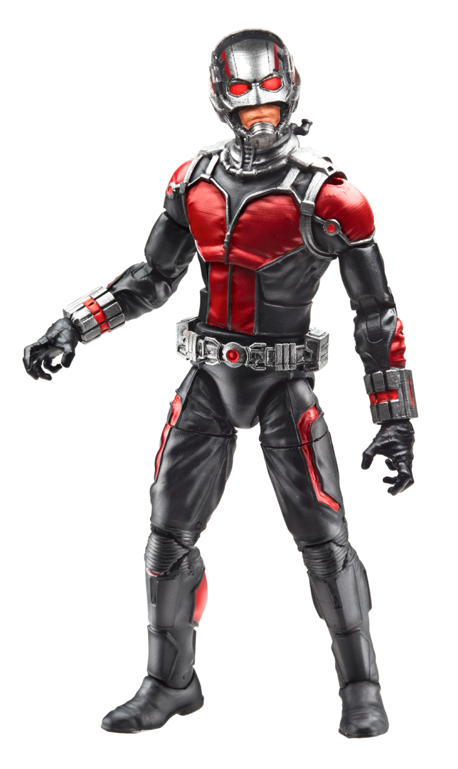
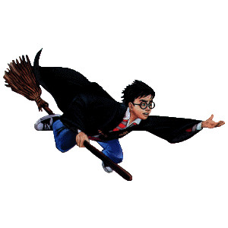
Literary Terms
Characters: People or animals about which the story is told.
Protagonist:

Antagonist:

Dynamic:
A character who __________________, or _____________________ throughout the story and is considered a _________________________ character.
Flat: A character that is barely ______________________________, few traits are known and the character is simply depicted with ______________________________ thoughts, actions, etc.
Round: A character that is __________________ ___________________ throughout the story and is ________________________ in his/her thinking, actions, etc.

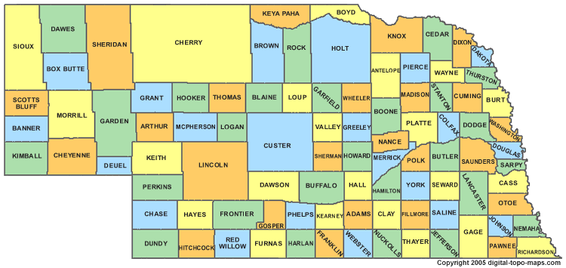

Setting: The time and place in which the action occurs.
Things to take into consideration when analyzing the setting are:
Time: _______________ the story happens
→ In _______________: past, present, future
→ ____________________: morning, dusk, night
→ ____________________: Fall, Spring, Christmas
Place: ___________________ the story happens
→ “___________________________” (Bellevue, NE)
→ “_____________________” (left up to the reader’s imagination—could be just
about anywhere)
Link to central conflict: (Specific _____________________ between the setting and the main conflict)

Plot: Exposition (___________________), ___________________, Climax, Falling Action, ____________________. All of this centers on at least one _________________ that the characters struggle to resolve.

4) Climax
→ The _________________ is directly
___________________

1) Exposition:
→ Introduces the ____________________________, ____________________________ and the ____________________________
→ Provides necessary background information
2) Exciting Force
→ The first _________________
_____________________ that
sparks action and moves the story forward.
6) Resolution
→ Tells how the story
__________________
→ Ties up lose ends
→ Short stories may
not have a resolution

3) Rising Action → _____________
is obvious
→ Complications arise
→ _____________
builds
5) Falling Action
→ ________________
of the _____________
are shown

Theme: The __________________ the writer presents through the _________________ and the ________________.
The theme often is about _______________ or a ___________________ learned by the
characters. (Hint: A theme cannot be stated in a word or two. It can, however, be
stated in a sentence or two. Stories usually have more than one theme.)
Common Theme Topics: Growing Up, Friendship, Determination, Courage

Mood: The _________________________ of the reader.
Examples:
Tone: The _________________________ of the author toward the subject. It usually reflects the author’s ______________________ or the character’s mood.
Examples:

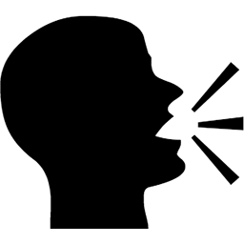
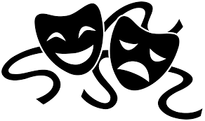

Purpose: The main ____________________ of the piece.
1) Inform
2) ________________
3) ________________
4) Express an Opinion

Foreshadowing:
A ______________ of something to come
Allusion:
A ________________________________to an outside literary work, famous ___________________ or well-known _______________________ event.
Irony: The ________________________ between what appears and what really is.

Verbal Irony:
The contrast between what is being _____________ and what
is actually ________________.
Situational Irony:
When things turn out
_________________ to what is
expected.
Dramatic Irony:
When the _________________
knows something the characters
do not.

Simile:
A ____________________ between two things using __________ or _________.

Example:
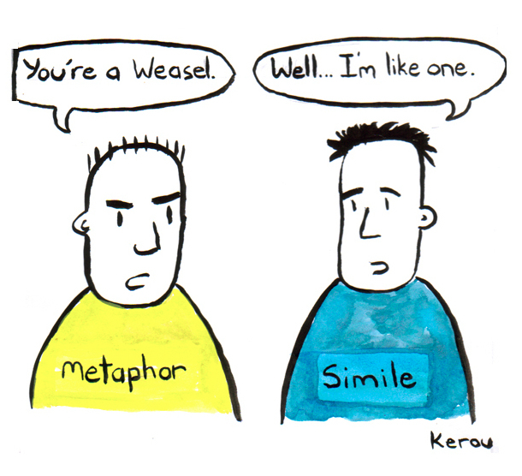

Metaphor:
Comparison between two unlike things that doesn’t use like or as.
Example:

Personification:
A phrase that gives ______________________ characteristics to inanimate/non-living objects.
Example:
Hyperbole:
An extreme ____________________________ used to add emphasis
Example:

