Native American Cultures: The Plateau
By Encyclopaedia Britannica, adapted by Newsela staff
Grade Level 6
06/21/2017

The Plateau Indians traditionally lived in the region between the Rocky Mountains and the Cascade Mountain Range and Canadian Coast Ranges on the west. The area includes parts of the present-day U.S. states of Montana, Idaho, Oregon and Washington and the Canadian province of British Columbia.
Most peoples of the Plateau traditionally spoke languages of the Salishan, Sahaptin, Kutenai, Modoc and Klamath families. Tribes that spoke Salishan languages are collectively known as the Salish. Some well-known tribes include the Nez Perce, Wallawalla, Yakima, Umatilla and Modoc.

Food
The Plateau Indians relied almost entirely on wild foods. Fishing was the most important food source. Fish were dried on wooden racks to preserve them for the winter food supply. They supplemented the fish catch by hunting. In the early 1700s, some Plateau groups started to hunt bison after receiving horses from their neighbors in the Great Basin.
Wild plant foods were another important part of the diet, especially roots and bulbs. The Plateau Indians cooked them in earth ovens heated by hot stones. They also harvested huckleberries, blueberries and other berries.

Villages And Houses
Plateau peoples lived in permanent villages in the winter. A village was home to between a few hundred and a thousand people. They were generally located on waterways, often at rapids or streams where fish were plentiful during the winter. During the rest of the year, many tribes divided their time between their villages and camps. The camps were set up in good hunting and gathering spots, often using movable homes like tepees.
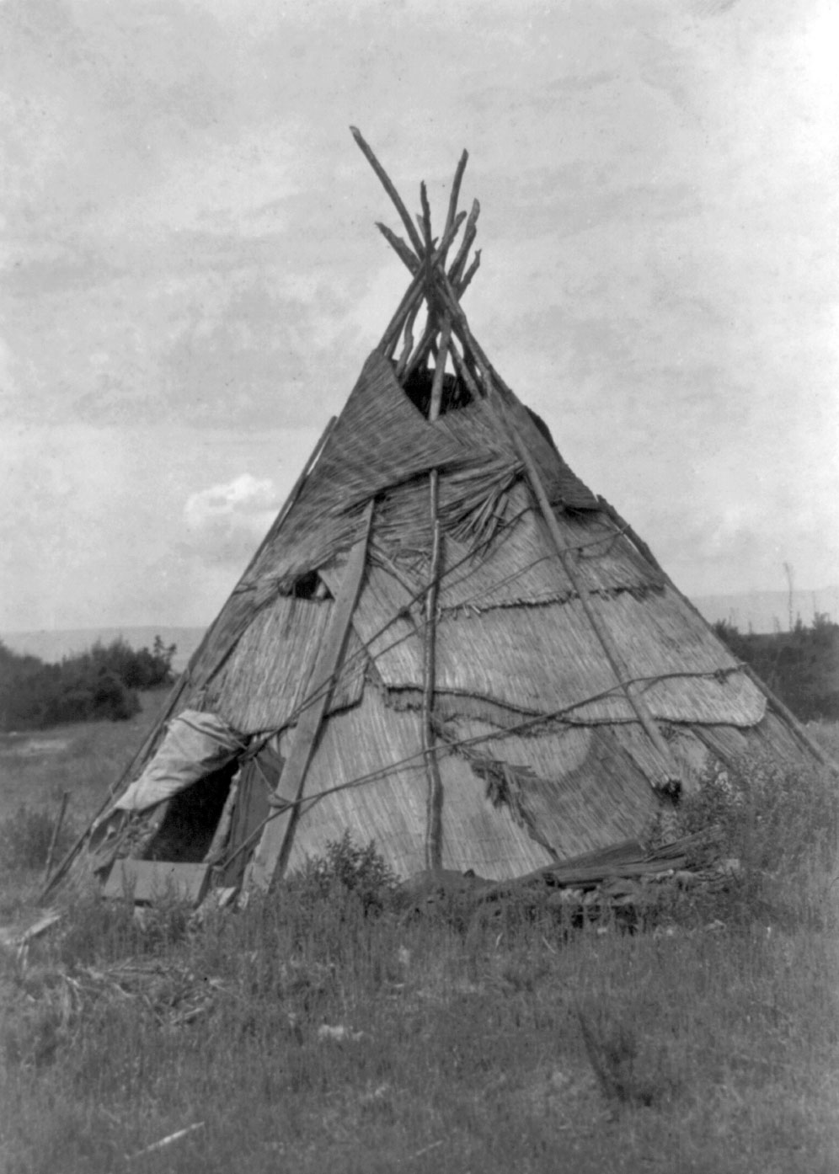Yakima home with reed mat cover. Photo: Edward S. Curtis, 1910. Library of Congress, Washington, D.C.[click to expand]
Village houses were of two main types, the pit house and the mat-covered surface house. Pit houses were usually circular and typically had a pit that was 3 to 6 feet deep. They had a cone-shaped roof and a smoke hole on top.
On the southern Plateau, the pit house was replaced by the mat-covered surface house. These homes were formed by leaning together poles and covering them with grass or mats made of a type of reed. They were used in the summer when people moved often in search of food. Each typically sheltered one family.

Clothing
Plateau peoples traditionally wore a bark apron and a bark poncho. In winter, men wrapped their legs with fur while women had leggings of hemp. They also used robes or blankets of rabbit or other fur. By the 1800s, they had traded with the Plains Indians for leather clothing. The Plateau peoples usually wore their hair braided. They also received fur caps and feathered headdresses from the Plains tribes.

Trade And Tools
Plateau Native Americans were continuously exposed to new items and ideas through trade with surrounding areas. They were skilled at adapting others’ technologies to their own purposes.
Plateau peoples navigated the rivers in dugout or bark canoes. Long-distance water travel was limited, however, by the many river rapids. Plateau fishermen used spears, traps and nets. Communities also built and held in common large fish pens made of stone or wood. Hunters used a bow and arrow and sometimes a short spear. In the winter, the hunters wore long and narrow snowshoes in order to track animals.

Society
Traditional Plateau societies were organized around villages. Different tribes had different ways of governing the village. The Ntlakapamux peoples, for example, decided everything together. The Sanpoil, on the other hand, had a more formal political structure with a chief, subchief and a general assembly where people could vote.
Among some groups, a sense of tribal and cultural unity reached beyond the village. These groups created representative governments, tribal chieftainships and confederations of tribes. They could work together because there was enough food for all.
Plateau culture emphasized the sharing of necessities, such as food. Communities owned fishing sites in common. Each village also had an area away from the river for hunting, which usually was open to people from other villages.
Family life, like other aspects of Plateau society, was marked by ceremonial acts beginning even before birth. Even as a small boy, a Sinkaietk could join his father on fishing and hunting trips. Small girls helped their mothers around the house and in gathering wild foods. Children learned to be hardy through activities such as swimming in cold streams.

Religion
Plateau religions shared several features with other native North American religions. One was animism, the belief that spirits lived in everything. Another was the idea that individuals could communicate personally with the spirit world. A third was the belief that people called shamans gained special powers through their contact with the spirits. Shamans healed the living and contacted the dead, earning them wealth, respect and even fear.
The main rituals were the vision quest, the firstling rites or first foods and the winter dance. The vision quest usually involved spending some days fasting on a mountaintop. The person on the quest hoped to communicate with a guardian spirit. The firstling rites celebrated and honored the first foods caught or gathered in the spring.

European Contact And Cultural Change
By the 1840s thousands of Euro-American settlers were heading west to what would become the Oregon Territory. Many of them traveled through the Plateau, often trespassing on tribal lands. Many tribal lands were taken away in a process called allotment.
Allotment ended in the 1930s, when new federal policies let tribes create their own governments. Many tribes wrote constitutions and elected councils during this period.
By the late 20th and early 21st centuries many Plateau tribes had come back economically. Several tribes had started new businesses. Funds from these businesses were used for the tribal community.

