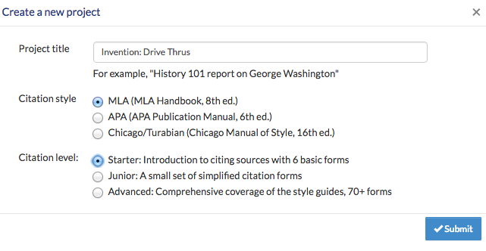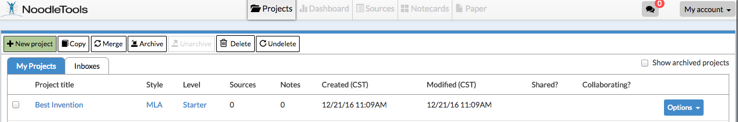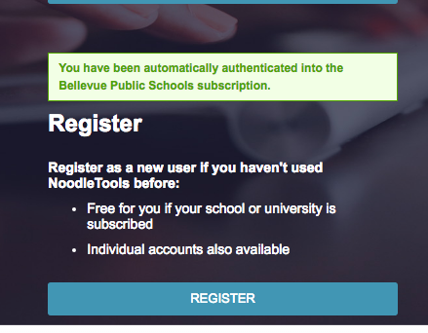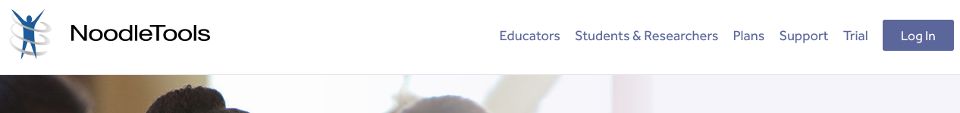[www.noodletools.com](http://www.noodletools.com)

**Title it with what you’re researching  
  
  
  
Choose MLA  
  
  
Choose: STARTER**

**Create a NEW PROJECT**

Unless you remember your login, click REGISTER and fill out the information to make an account.

User name: firstname.lastname

Password: bps + ID #

<http://nebraskaccess.ne.gov/>

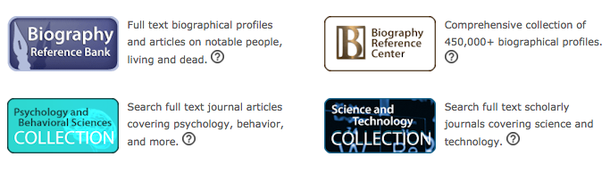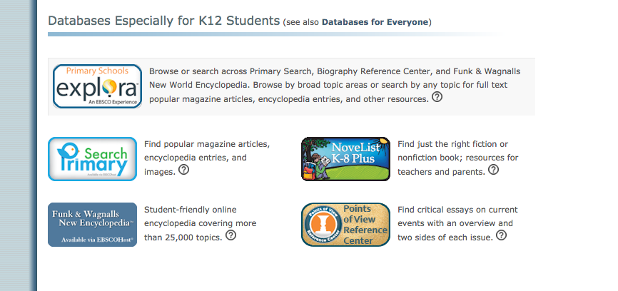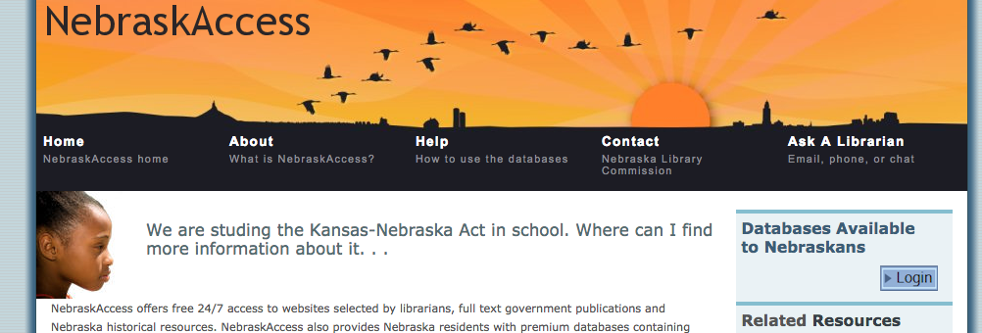

**You MUST find at least TWO sources from a database.**

**(You’ll need a NE Drivers License # if logging in at home.)**