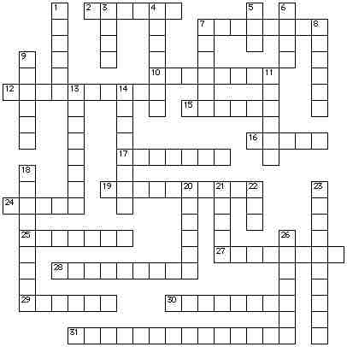

ACROSS
2. Odysseus' home
7. the Phaeacian king who hosts Odysseus
10. Polyphemus’ father
12. the Cyclops blinded by Odysseus
15. the messenger of the gods
16. the flowery fruit that can make men forget their homes
17. father of Odysseus
19. prominent suitor who is the arch-enemy of Telemachus
24. imprisoned Odysseus's men in a pig sty before becoming his lover
25. member of Odysseus crew who is encountered in the underworld
27. young daughter of Alcinous who is tall and beautiful as a goddess
28. sucked down salt water exposing her interior vortex then vomited it up seething over like a cauldron over a blazing fire
29. Odysseus had to be tied down to listen to their song
30. the god whose cattle was consumed by Odysseus' crew
31. giants who pelted rocks down on the ships of Odysseus' expedition
DOWN
1. person who claimed responsibility for the Cyclops' suffering
3. where Odysseus' journey home began
4. Nymph, envied by the gods for living with a mortal, who delays Odysseus for seven years
5. Eumaeus takes care of this animal in the pasture
6. herb with black roots and a white blossom given to Oydesseus by Hermes
7. goddess who protects and helps Odysseus
8. creature with a dreadful bark, twelve feet, six scrawny necks and triple rows of fangs
9. father of Zeus
11. king of Pylos; the Gerenian Charioteer visited by Telemachus
13. wife of Odysseus
14. husband of Helen and host of Telemachus
18. blind Theban prophet from whom Odysseus sought advice in Hades
20. gave Odysseus a leather bag containing the boisterous energies of the wind
21. beautiful wife of Menelaus
22. relationship of Telemachus to Odysseus
23. The god of metalworking and fire
26. the people who were raided during Odysseus' first stop on his return from war

