English 9 Advanced
with Mrs. Muldoon

Specific Grading Information:
Students will not be given another opportunity to re-take novel assessments or semester finals as multiple formative assessments/and or check points have been in place leading to this activity.

Summative writing assessments (with the exception of the research paper) may be re-written after a formal re-learning process determined by the teacher. The new score will be entered.

Formative Work: late work will be accepted to the end of the unit for reduced credit of 40%.

Summative Projects and Essays: 10% a day will be deducted for each late day. Due to the length of the unit and the scaffolds in place to support the timely completion of the work, late submission of the research paper/project will result in significant credit deduction as determined by the teacher.

Speeches are Essential Objectives and are course requirements. Students will be offered accommodations as determined by an IEP or 504 plan, but otherwise will give the speech in front of the class or GPS as determined by the teacher.
A = 90-100
B = 80-89
C = 70-79
D = 60-69
F = 0-59

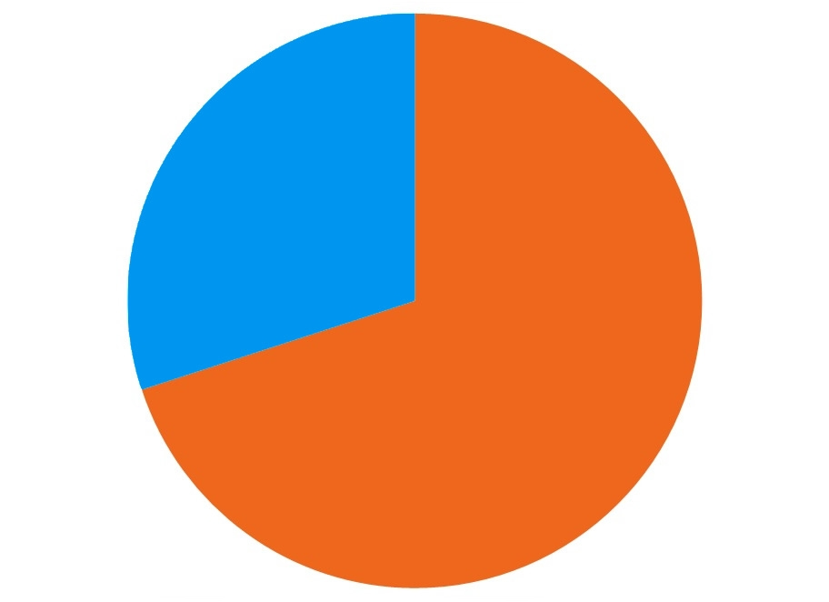
Other information you should know about English 9A:
- Inappropriate use of technology will not be tolerated. I will send the
device to the dean and your student will pick it up there at the end of
the day.
- Late work will be accepted until the end of the unit; however, it will
not be worth full-credit. After the unit is over, formative work will no
longer be accepted. More grading information can be found on my website.
- I update the class website multiple times a week. Students can find
copies of worksheets, directions, unit calendars/due dates, and
additional videos/explanation to the day’s lesson.
About Me:
I’m Kristen Muldoon. I am married and have a 10-month-old son named Luke. I love reading especially Harry Potter, dystopian novels, and John Green. I drink coffee every morning and Diet Coke every afternoon. I graduated from UNL (Go Big Red!) and am currently working on my Master’s in Literacy at UNO. This will be my 4th year teaching at BWHS; I am excited to be your student’s freshmen English teacher
Contact Information:
Email:
kristen.muldoon@bpsne.net
Website:
muldoonenglish.weebly.com
Team Email:
west.thunder@bpsne.net
Team Website:
bwteamthunder.weebly.com
Throughout the year we will write four major essays:
- Narrative Essay
- Expository Essay
- Persuasive Essay
- Literary Analysis Essay
We will also focus on perfecting paragraph structure, composing annotated bibliographies, and creating poetry.
We will also learn to research and present ideas:
- Career Center Exploration + Speech with visual aid
- Research a controversial topic to learn how: to find credible sources, to
cite sources correctly, to write annotated bibliography entries, to create
an MLA outline, to present ideas respectfully
(Tests, projects, essays,
speeches)
70%
Summative
30%
Formative
(Homework, quizzes, reading checks)
Throughout the year we will read:
- short stories
- Speak by Laurie Halse Anderson
- Absolutely True Diaries of a Part-Time Indian by Sherman Alexie
- The Odyssey by Homer
- a non-fiction novel (they will be able to choose from an assortment)
- A Tale of Two Cities by Charles Dickens
- Romeo & Juliet by Shakespeare
- a fiction novel (they will be able to choose from an assortment)
- poetry
- two other free-read novels of their choice

