AP Language and Composition
Passive and Active Voice
Taken from THE LIVELY ART OF WRITING by Lucile Vaughan Payne

Active Voice
In sentences written in active voice, the subject performs the action expressed in the verb; the subject acts.
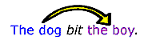
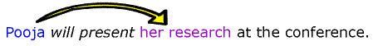
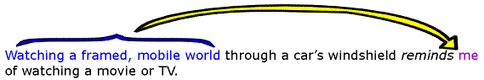

In each example above, the subject of the sentence performs the action expressed in the verb.

Passive Voice
In sentences written in passive voice, the subject receives the action expressed in the verb; the subject is acted upon. The agent performing the action may appear in a "by the . . ." phrase or may be omitted.
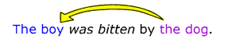
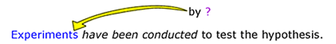
(agent performing action has been omitted.)
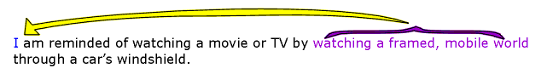

Sometimes the use of passive voice can create awkward sentences, as in the last example above. Also, overuse of passive voice throughout an essay can cause your prose to seem flat and uninteresting. In scientific writing, however, passive voice is more readily accepted since using it allows one to write without using personal pronouns or the names of particular researchers as the subjects of sentences (see the third example above). This practice helps to create the appearance of an objective, fact-based discourse because writers can present research and conclusions without attributing them to particular agents. Instead, the writing appears to convey information that is not limited or biased by individual perspectives or personal interests.
You can recognize passive-voice expressions because the verb phrase will always include a form of be, such as am, is, was, were, are, or been. The presence of a be-verb, however, does not necessarily mean that the sentence is in passive voice. Another way to recognize passive-voice sentences is that they may include a "by the..." phrase after the verb; the agent performing the action, if named, is the object of the preposition in this phrase.

Choosing Active Voice
In most nonscientific writing situations, active voice is preferable to passive for the majority of your sentences. Even in scientific writing, overuse of passive voice or use of passive voice in long and complicated sentences can cause readers to lose interest or to become confused. Sentences in active voice are generally--though not always-- clearer and more direct than those in passive voice.
passive (indirect) | active (direct):
 | 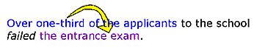
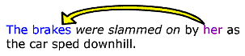 | 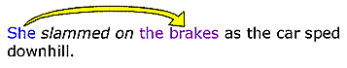
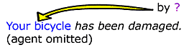 | 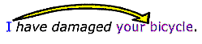
Sentences in active voice are also more concise than those in passive voice because fewer words are required to express action in active voice than in passive.
passive (more wordy) | active (more concise)
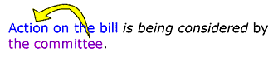
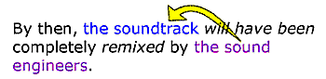 | 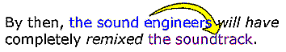

Changing passive to active
If you want to change a passive-voice sentence to active voice, find the agent in a "by the..." phrase, or consider carefully who or what is performing the action expressed in the verb. Make that agent the subject of the sentence, and change the verb accordingly. Sometimes you will need to infer the agent from the surrounding sentences which provide context.
Passive Voice | Agent | Changed to Active Voice
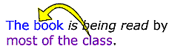 | most of the class
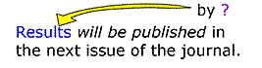 | agent not specified; most likely agents such as "the researchers" | 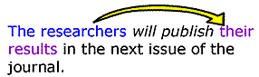
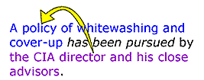 | the CIA director and his close advisors
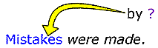 | agent not specified; most likely agents such as "we"

Choosing Passive Voice
While active voice helps to create clear and direct sentences, sometimes writers find that using an indirect expression is rhetorically effective in a given situation, so they choose passive voice. Also, as mentioned above, writers in the sciences conventionally use passive voice more often than writers in other discourses. Passive voice makes sense when the agent performing the action is obvious, unimportant, or unknown or when a writer wishes to postpone mentioning the agent until the last part of the sentence or to avoid mentioning the agent at all. The passive voice is effective in such circumstances because it highlights the action and what is acted upon rather than the agent performing the action.
active | passive
The dispatcher is notifying police that three prisoners have escaped. | Police are being notified that three prisoners have escaped.
Surgeons successfully performed a new experimental liver-transplant operation yesterday. | A new experimental liver-transplant operation was performed successfully yesterday.
"Authorities make rules to be broken," he said defiantly. | "Rules are made to be broken," he said defiantly.
In each of these examples, the passive voice makes sense because the agent is relatively unimportant compared to the action itself and what is acted upon.

Changing active to passive
If you want to change an active-voice sentence to passive voice, consider carefully who or what is performing the action expressed in the verb, and then make that agent the object of a "by the..." phrase. Make what is acted upon the subject of the sentence, and change the verb to a form of be + past participle. Including an explicit "by the..." phrase is optional.
Active Voice | Agent | Changed to Passive Voice
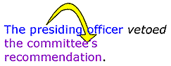 | The presiding officer | 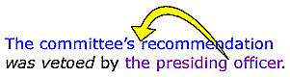
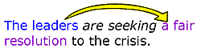 | The leaders | 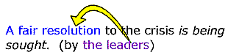
 | The scientists | 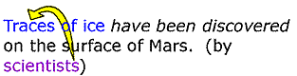
In each of these examples, the passive voice is useful for highlighting the action and what is acted upon instead of the agent.

Some suggestions
1. Avoid starting a sentence in active voice and then shifting to passive.
Unnecessary shift in voice | Revised
Many customers in the restaurant found the coffee too bitter to drink, but it was still ordered frequently. | Many customers in the restaurant found the coffee too bitter to drink, but they still ordered it frequently.
He tried to act cool when he slipped in the puddle, but he was still laughed at by the other students. | He tried to act cool when he slipped in the puddle, but the other students still laughed at him.
2. Avoid dangling modifiers caused by the use of passive voice. A dangling modifier is a word or phrase that modifies a word not clearly stated in the sentence.
Dangling modifier with passive voice | Revised
To save time, the paper was written on a computer. (Who was saving time? The paper?) | To save time, Kristin wrote the paper on a computer.
Seeking to lay off workers without taking the blame, consultants were hired to break the bad news. Who was seeking to lay off workers? The consultants?) | Seeking to lay off workers without taking the blame, the CEO hired consultants to break the bad news.
3. Don't trust the grammar-checking programs in word-processing software. Many grammar checkers flag all passive constructions, but you may want to keep some that are flagged. Trust your judgment, or ask another human being for their opinion about which sentence sounds best.

Active Tenses
Simple Present | Present Progressive | Simple Past | Past Progressive | Future | Present Perfect | Present Perfect Progressive | Past Perfect | Future Perfect

Passive Tenses
Simple Present | Present Progressive | Simple Past | Past Progressive | Future
Present Perfect | Past Perfect | Modals | Subject/Object | By

