Complete sentences have a SUBJECT and a VERB.
In the examples below, first determine if the sentence is a complete sentence or a fragment. Then underline the SUBJECT and circle the VERB.
1. __________ Kayla loves driving her sparkly, red convertible.
2. __________ The black iPhone 6S.
3. __________ Even though he studied, John still failed the test.
4. __________ Since the lightning struck my house.
5. __________ The squirrel’s bushy tail got caught in the electric fence.

Now… choose one of the fragments above and make it into a complete sentence.
6. ___________________________________________________________________________________________________________

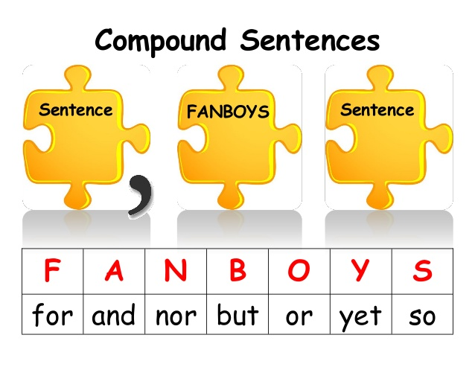
But sometimes… people combine multiple sentences into ONE, which makes a RUN-ON SENTENCE. These make my heart cry, but luckily there are multiple ways to fix this mistake.
The SECOND WAY: Add a comma before a coordinating conjunction.
Add a comma before the coordinating conjunction, but ONLY IF there’s a complete sentence on BOTH sides of the conjunction.
7. Latifah practiced the audition song and the scales on her flue.
8. Nick hated the first day of basketball practice but he went back the next day anyway.
9. I love fountain Diet Coke so I regularly stop at Hy-Vee Gas after school to buy one.
10. Patricia doesn’t like grilled asparagus or fried green beans.
,
Combine the following sentences using a COMMA and the coordinating conjunction that best combines the two ideas.
Sentence
Sentence
F = ________________
A = ________________
N = ________________
B = ________________
O = ________________
Y = ________________
S = ________________

11. Martina heard a knock at the door. She opened it.
_________________________________________________________________________________________________________________________
12. It was raining. The children were playing outside anyway.
_________________________________________________________________________________________________________________________
13. Our English paper focuses on Odysseus. It has to be seven pages long.
_________________________________________________________________________________________________________________________
14. Odysseus is smart. He still gets himself into tricky situations.
_________________________________________________________________________________________________________________________
15. Scylla has six mouths full of sharp teeth. She eats one man for each mouth.
_________________________________________________________________________________________________________________________
16. Odysseus’ men will die. They will live.
_________________________________________________________________________________________________________________________
Fix the run-on sentences using either of the two methods we’ve learned so far.
FIRST WAY: Add a period in the correct place and capitalize the next letter.
SECOND WAY: Add a comma and/or a coordinating conjunction.

17. The other day I drove to Starbucks I ordered a caramel latte.
18. The sun’s rays were bright but it was still cold.
19. Circe, a goddess, gets Odysseus to stay with her for a whole year eventually, he leaves.
20. In order for Odysseus to leave, Circe asks him to visit the Underworld Odysseus visits Tiresias and others in the Underworld.

